You Say You Want a Revolution? Records & Rebels 1966 – 1970
Sennheiser delivers truly immersive sound at the Melbourne Museum
Melbourne, 26 April 2019 – Sennheiser is collaborating with the Melbourne Museum on the fantastic exhibition ‘You Say You Want a Revolution? Records & Rebels 1966 – 1970’. The exhibit originates from the Victoria and Albert Museum (V&A) in London, the world’s leading museum of art, design and performance. Sennheiser is providing the sound experience for the exhibition, using the innovative AMBEO 3D audio technology which will immerse visitors in the music and spirit of that era. These groundbreaking 3D sound installations promise to truly immerse visitors in the experience. Furthermore, guests will be given a personal Sennheiser audio guide system that will deliver the soundscape of the exhibit.

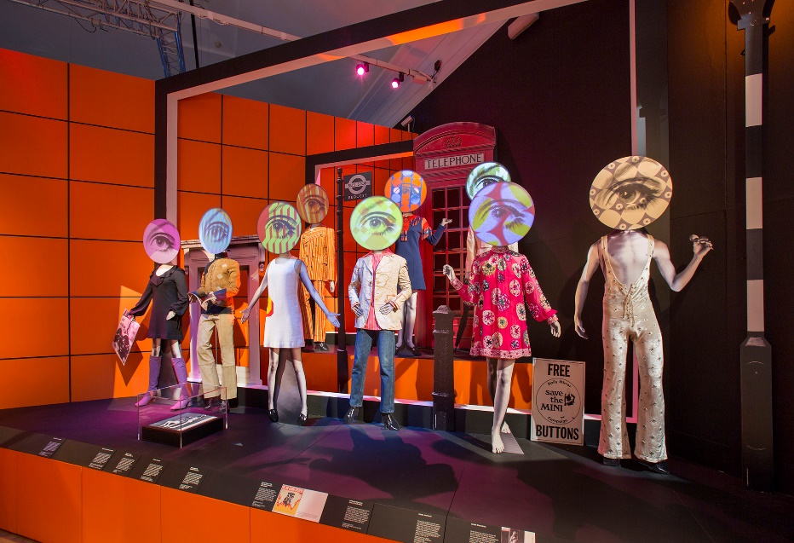 | Inside the ‘Revolutions: Records & Rebels’ exhibition, showcasing some of the key fashion pieces on display.  ©Victoria and Albert Museum, London

‘Revolutions: Records & Rebels’ will be open to the public at Melbourne Museum on Saturday 27th April. Curated by Geoffrey Marsh and Victoria Broackes from the V&A, the exhibition explores the transformative era of the late sixties through hundreds of pieces from the V&A’s extensive collections, as well as pieces from Museums Victoria’s own collection. These are presented alongside a selection of world class loans, which range from design, music, film, fashion and consumer products to photography, posters and books.

Co-curator Victoria Broackes explained that music plays a key role in the exhibition: “The music running through ‘You Say You Want a Revolution? Records & Rebels 1966 – 1970’ represents the backbone and heart of the exhibition; it is an object in itself. Therefore, we are delighted to be working with Sennheiser once again. Their expertise in 3D immersive audio has pushed the limits of the sound experience still further.”

Jason Grbevski, Product Channel Manager for Integrated Solutions at Sennheiser Australia, commented: “We are very excited to see this exhibition come to life in Melbourne, Australia’s unofficial capital for culture, music and the arts, after its amazing success at the Victoria and Albert Museum. Being such a transformational time in our more recent history, we are eager to be involved with telling this story and bringing it to life with sound. Visitors will be fully immersed in this spectacular and artistic exhibition with a truly innovative sound experience from Sennheiser, featuring our AMBEO 3D audio technology.”

Immersive AMBEO installation
The Sennheiser team, led by system designer Robert Genereux, worked closely with the V&As sound designer Carolyn Downing to set up the AMBEO 3D audio soundscape, and is again bringing this sound experience to life with the team at the Melbourne Museum. The AMBEO installation is recreating the legendary Woodstock festival. With music being the uniting element of the world’s youth at the time, Woodstock was much more than just a music festival – it embodied an alternative way of life. This special concert atmosphere is recreated with a 14.1 AMBEO installation that uses up-mixed audio material from the period. The installation truly immerses visitors into the live music soundscape, delivering the full emotional impact of the performance as if they were experiencing the concert first hand.

The visitor’s companion: an audio guide
Visitors are accompanied through the exhibition by a Sennheiser audio guide system, which will be handed out to each individual as they enter the exhibit. The audio guide system is unique in its ability to deliver hundreds of personal, automatically triggered stereo feeds simultaneously. It transmits real-time, lip-sync audio to fully immerse visitors in the sights and sounds of the late 1960s. The system comprises 600 receiver units with high-quality headphones, along with several transmission and trigger units that will be hidden from sight to create a seamless sound experience for every visitor.

‘You Say You Want a Revolution? Records and Rebels 1966 – 1970’ runs at the Melbourne Museum 27th April 2019 to 25th August 2019.

About Sennheiser
Sennheiser is shaping the future of audio – a vision built on more than 70 years of innovation culture, which is deeply rooted within the family-owned company. Founded in 1945, Sennheiser is one of the world’s leading manufacturers of headphones, microphones and wireless transmission systems. With 20 sales subsidiaries and long-established trading partners, the company is active in more than 50 countries and operates its own production facilities in Germany, Ireland and the USA. Sennheiser has around 2,800 employees around the world that share a passion for audio excellence. Since 2013, Sennheiser has been managed by Daniel Sennheiser and Dr. Andreas Sennheiser, the third generation of the family to run the company. In 2016, the Sennheiser Group had sales totaling €658.4 million. www.sennheiser.com

Press contact

Heather Reid
PR Manager Australia & New Zealand
heather.reid@sennheiser.com
+61 448 119 609

About Melbourne Museum
Melbourne Museum offers visitors unparalleled insight into Victoria’s histories, cultures and natural
environment from a range of perspectives. Behold globally-recognised exhibitions such as First Peoples,
Te Vainui O Pasifika, Bugs Alive!, 600 Million Years, The Mind and Dinosaur Walk, along with brilliant
temporary and touring exhibitions from near and far. Originally situated in the State Library of Victoria
on Russell Street, Melbourne Museum re-opened in its Carlton Gardens location on 21 October 2000.
Designed by Denton Corker Marshall, this iconic structure houses spaces such as Bunjilaka Aboriginal
Cultural Centre, Te Pasifika Gallery, the Forest Gallery, the Science and Life Gallery, the Melbourne Gallery
and the Children’s Gallery.

For more information about ‘You Say You Want a Revolution? Records and Rebels 1966 – 1970’, please contact Jacqui Wilson the Media and Communications Manager for the Melbourne Museum via media@museum.vic.gov.au or +61 (0)466 622 621

